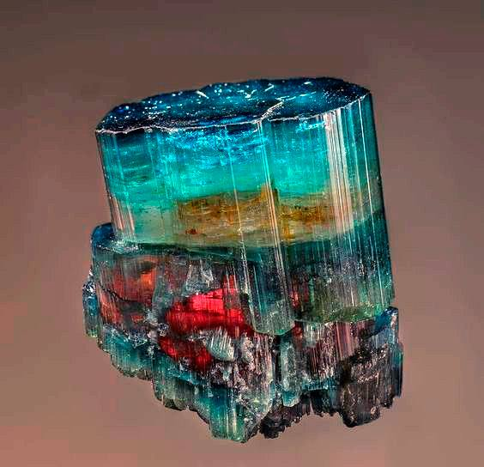  Tourmaline  Location: Sapo Mine, Ferruginha, Conselheiro Pena, Doce valley, Minas Gerais, Brazil  Tourmaline is a crystalline boron silicate mineral compounded with elements such as aluminum, iron, magnesium, sodium, lithium, or potassium. Tourmaline is classified as a semi-precious stone and the gemstone comes in a wide variety of colors. The word Tourmaline comes from Sri-Lanka for stone of mixed colors  Hardness: 7 Luster: Vitreous Weight: 90gr  Dimensions: 34mm x 38mm x 17mm  Retail Value: $1700  Purchase Price: $1200  Index # 00100-01
  Tourmaline 100-01
  Sapo Mine, Minas Gerais, Brazil
  Tourmaline
  Sapo Mine, Minas Gerais, Brazil
  Tourmaline
  Sapo Mine, Minas Gerais, Brazil
  Tourmaline
  Sapo Mine, Minas Gerais, Brazil
  Tourmaline
  Sapo Mine, Minas Gerais, Brazil
  Tourmaline
  Sapo Mine, Minas Gerais, Brazil
  Tourmaline
  Sapo Mine, Minas Gerais, Brazil
  Tourmaline
  Sapo Mine, Minas Gerais, Brazil
  Tourmaline
  Sapo Mine, Minas Gerais, Brazil
  Tourmaline
  Sapo Mine, Minas Gerais, Brazil
  Tourmaline
  Sapo Mine, Minas Gerais, Brazil
  Tourmaline
  Sapo Mine, Minas Gerais, Brazil
  Tourmaline
  Sapo Mine, Minas Gerais, Brazil
  Tourmaline
  Sapo Mine, Minas Gerais, Brazil

